AFFIDAVIT OF TRUTH
Bill Already Paid in Full
NOTICE TO AGENT IS NOTICE TO PRINCIPAL.
NOTICE TO PRINCIPAL IS NOTICE TO AGENT.

U.S.P.S. REGISTERED MAIL TRACKING NO.: RE xxx xxx xxx US

Date: Date Goes Here, 2023

To: C.F.O. / C.E.O. for  CORPORATION NAME  4321 THEIR ADDRESS HERE  CITY, ST 12345  Respondent | From: First Middle Last for  FIRST MIDDLE LAST, Estate  c/o 1234 Your Address Street  City, State Republic, near [12345]  Non-domestic  Principal

RE: Account Number xxxxxxxxxxxx

Dear Sir / Madam:

Your payment coupon of statement is being accepted and returned for value as consideration for settlement and closure of this account for the full amount of $(total owed) principal balance. It has been noted on the payment coupon that this coupon is a 100% value coupon and that it is accepted for the value indicated. I wish to thank you for obtaining the funds from my government-created ‘Cestui Que Vie Trust’ account for me, but you could have informed me about this process a long time ago.

The required I.R.S. form 1099-A is attached to document/cover the process of this transaction for the funds that you have withdrawn from U.S. Treasury CESTUI QUE VIE Trust Account – FIRST MIDDLE LAST (CESTUI QUE VIE TRUST), S.S.N. # 123-45-6789. The 1099-A is included so the I.R.S. accounting department can properly account for the transfer of these funds from this account to your account.

The first item on the 1099-A is for an Acquisition means for the Lender (buyer, purchaser, acquirer) and the Borrower (seller, supplier, provider). By the correct understanding of the form, the Negotiable Debt Instrument as noted thereon can actually be used for payment, and this 1099-A is documenting that fact.

If your company finds a defect with the Negotiable Debt Instrument, Principal requires the return of the Negotiable Debt Instrument along with a full written explanation by affidavit and under penalty of perjury within ten (10) days of your receipt of this Notice. Please seek legal counsel regarding this presentment should you have any questions. If your response is not written to this proper location, your mail did not meet proper service and shall be returned to its sender as soon as possible. So please update my mailing location as well as send me a “True Invoice”, NOT a statement of a bill which is a direct violation of your fiduciary duties.

A little extra information for the Respondent:
BE INFORMED: Any actor, agent, or fiduciary who delays, restricts, or otherwise prohibits the movement of this Negotiable Debt Instrument in its lawful progression* destined to or for the Holder in Due Course, Secured Party, or Claimant must show cause why a contempt charge** should not be issued against him/her in his/her/their true character or suffer the consequences of said action or lack of action. The breach of fiduciary duties also incurs civil liability subject to the posted Fee Schedule for Principal.

It is noted that said actors, agents, and fiduciaries are subject to the self-executing regulations of the 3rd and 4th sections of the 14th Amendment to the Bill of Rights to the Constitution for the united states of America whereby their offices are vacated, and their salaries and retirement benefits are extinguished when they do not perform the duties of said offices.

* established in 1933 under HJR-192 and exercised by actors, agents, and fiduciaries of every commercial transaction by commercial banking institutions since that date of the “Abrogation of the Gold Clause”
** damages equal to double the amount of the Negotiable Debt Instrument (under civil action) or triple the amount of the Negotiable Debt Instrument (under Admiralty Jurisdiction).

Copies of all paperwork shall be forwarded to:

To: INTERNAL REVENUE SERVICE  AUSTIN SUBMISSION PROCESSING  CENTER **SEE BELOW**  P.O. BOX # 149213  AUSTIN, TX 78714 | To:  I.R.S. TECHNICAL SUPPORT DIVISION  C/O TREASURY U.C.C. CONTRACT  TRUST  INTERNAL REVENUE SERVICE  1500 PENNSYLVANIA AVE. NW  WASHINGTON, DC 20220

To: Principal
[address listed above]

Thank you for your assistance in this matter.

Sincerely,

By:_________________________________ Date:_____________, 2023 A.D.
First Middle Last, Authorized Representative
Natural Person, in propria persona, sui juris
All Rights Reserved, Without Prejudice, U.C.C. § 1-207, 1-308, 1-103

**I.R.S. ADDRESSES FOR YOUR STATE:**
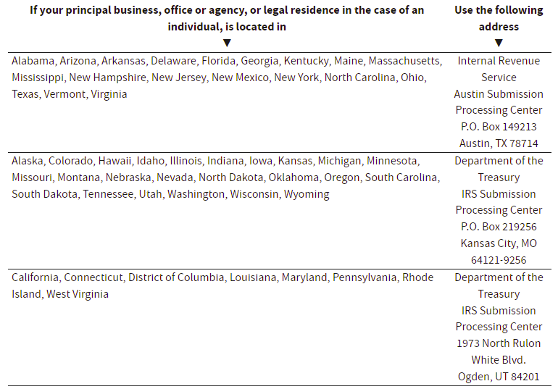
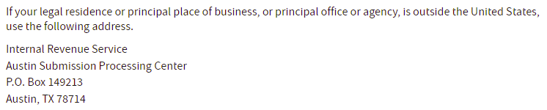
DELETE THIS AND ALL HIGHLIGHTED TEXT AFTERWARD

